The Azores are a volcanic archipelago composed by nine islands located in the middle of the North Atlantic Ocean and ranging between 37˚-40˚N and 25˚-31˚W. AG is the Geologic age Myr means million years.
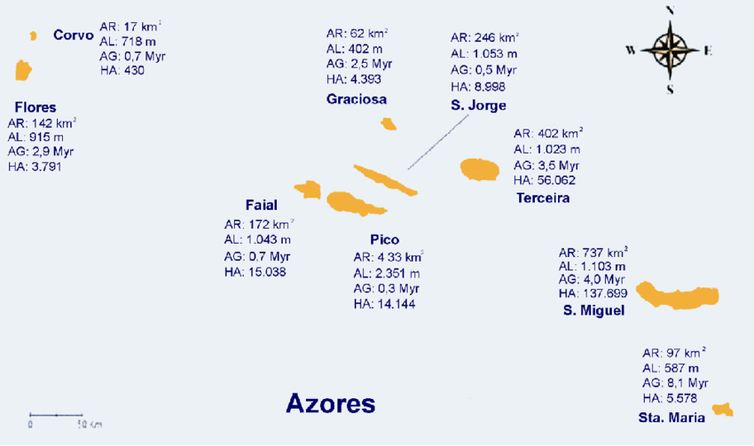

KERGUELEN HOTSPOT Ma means million years (age of rock)
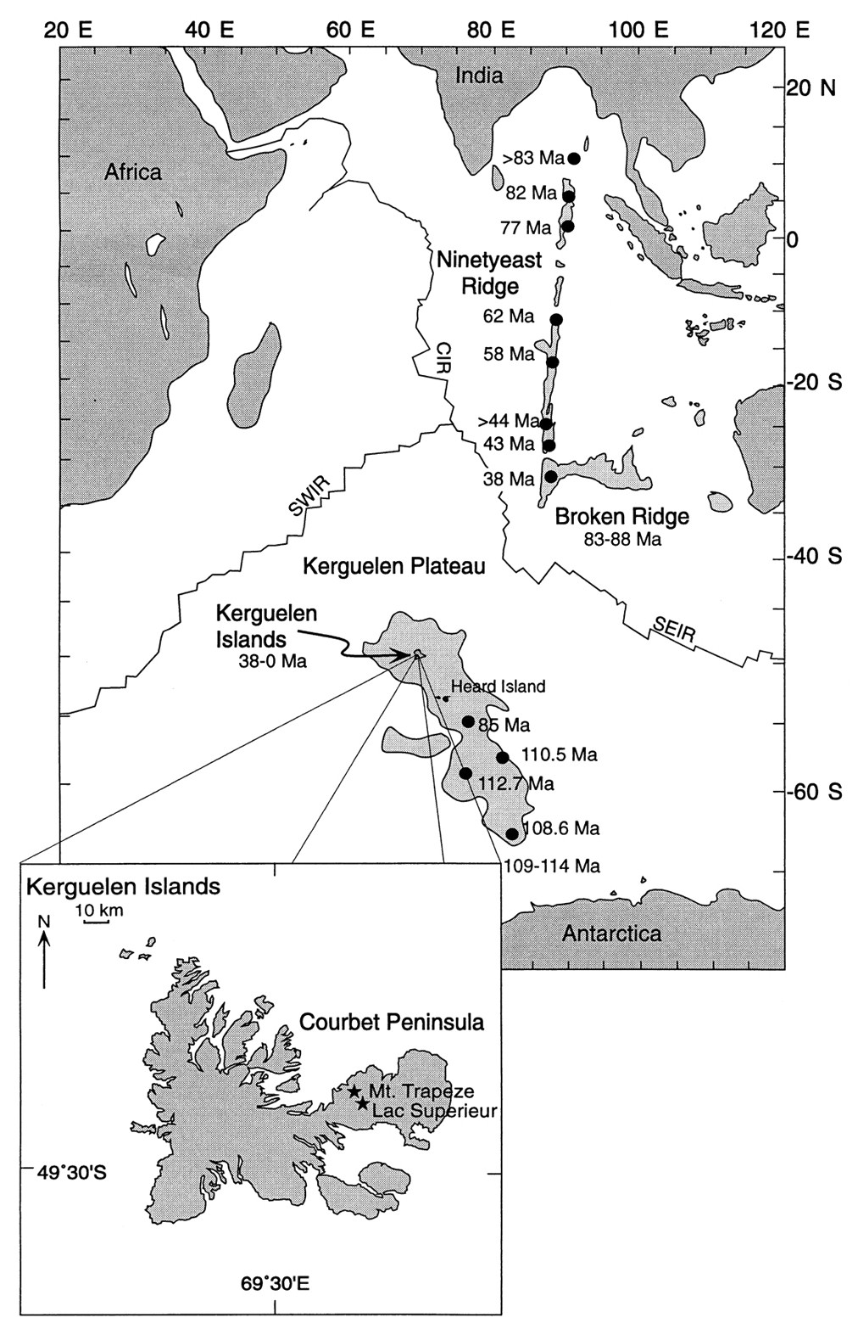

REUNION ISLAND HOTSPOT
