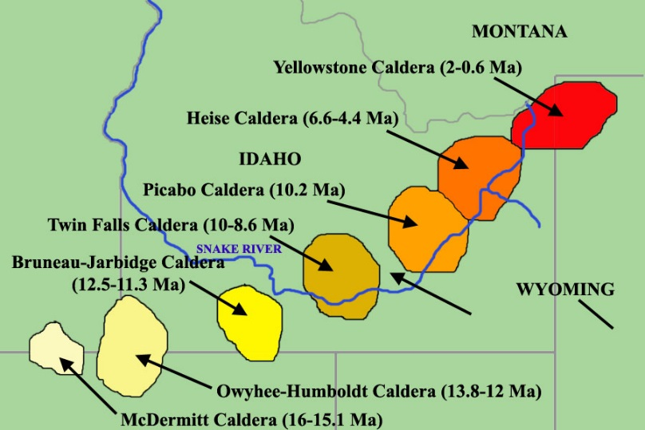

🡨 Yellowstone hotspot

Caldera formations

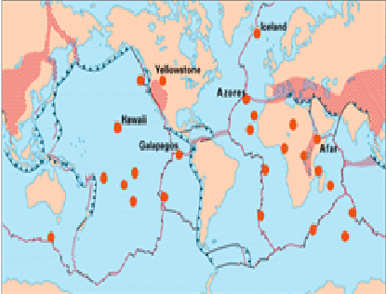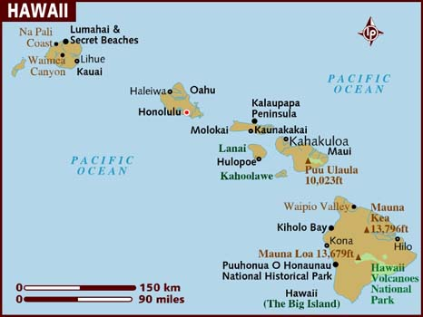🡸

🡸Hot spots Worldwide

🡸 Hawaiian Islands- Hawaii hotspot